lab 4
Areesha Raheel
Sap id:55039
Question:
Select any 5 Kali Linux tools of your own choice (excluding the tools discussed in class).

1. WHOIS
Objective: To collect domain registration information.
Method: WHOIS query.
Result: Domain registrar details and name servers were identified.
Security Impact: Publicly available information can aid attackers during reconnaissance.
Risk Level: Low
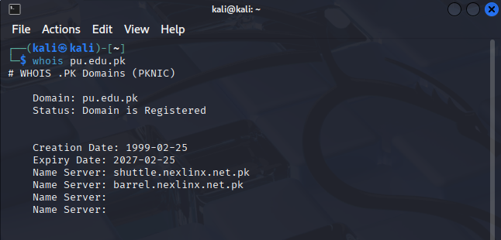

2. nslookup
Objective:To obtain DNS-related information of the target domain.
Method Used:The nslookup command was used to query DNS servers for domain resolution details.
Result:The IP address and DNS records associated with the target domain were successfully retrieved.
Security Impact:DNS information disclosure assists attackers in mapping the target infrastructure.
Risk Level:Low

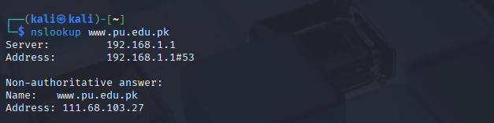

DNSenum
Objective: To enumerate DNS records and subdomains.
Method: DNS enumeration techniques.
Result: DNS records and additional subdomains were identified.
Security Impact: Exposed DNS information may help attackers map the infrastructure.
Risk Level: Low
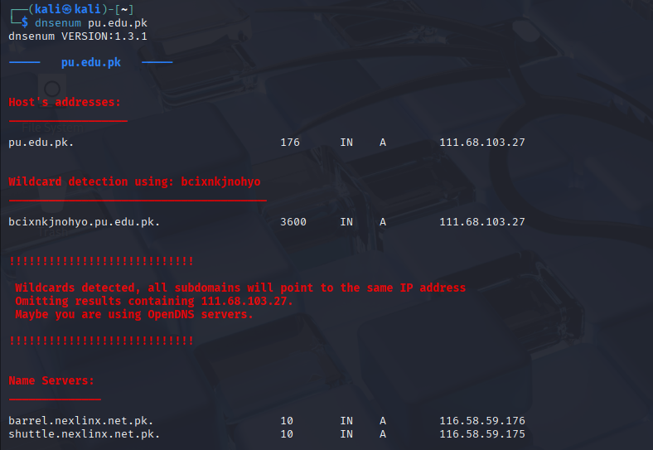
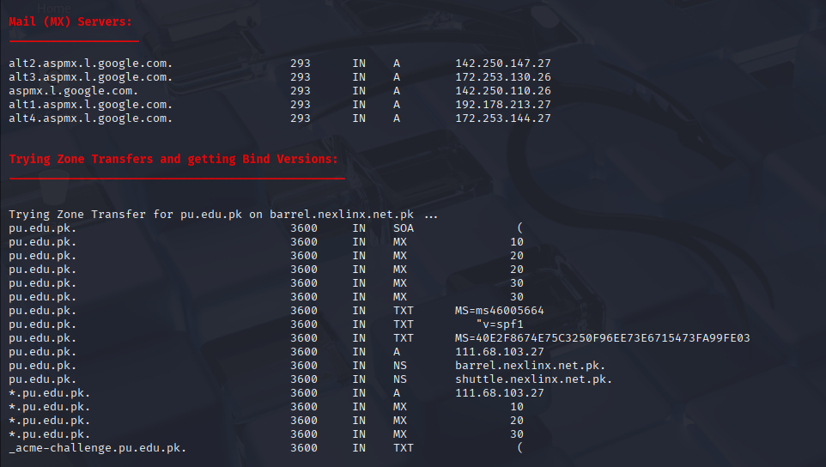

1. Nmap
Objective: To identify open ports and running services.
Method: TCP SYN scan and service detection.
Result: Several open ports and active services were detected.
Security Impact: Open services may be targeted if misconfigured.
Risk Level:Medium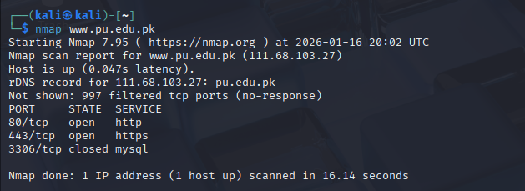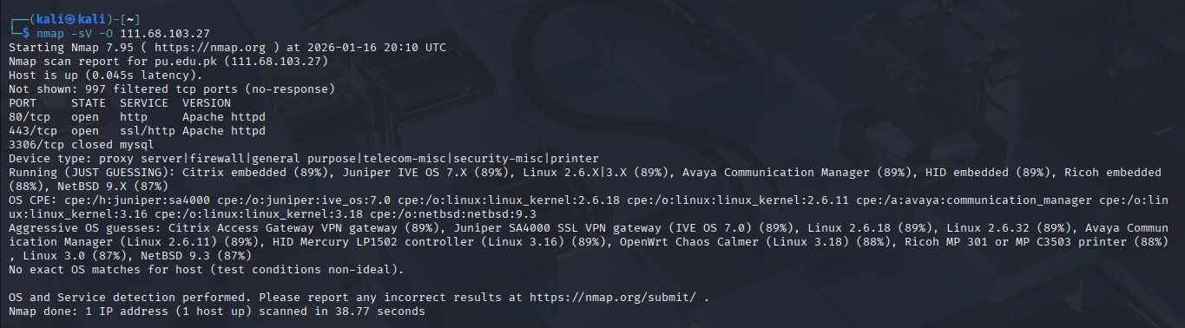
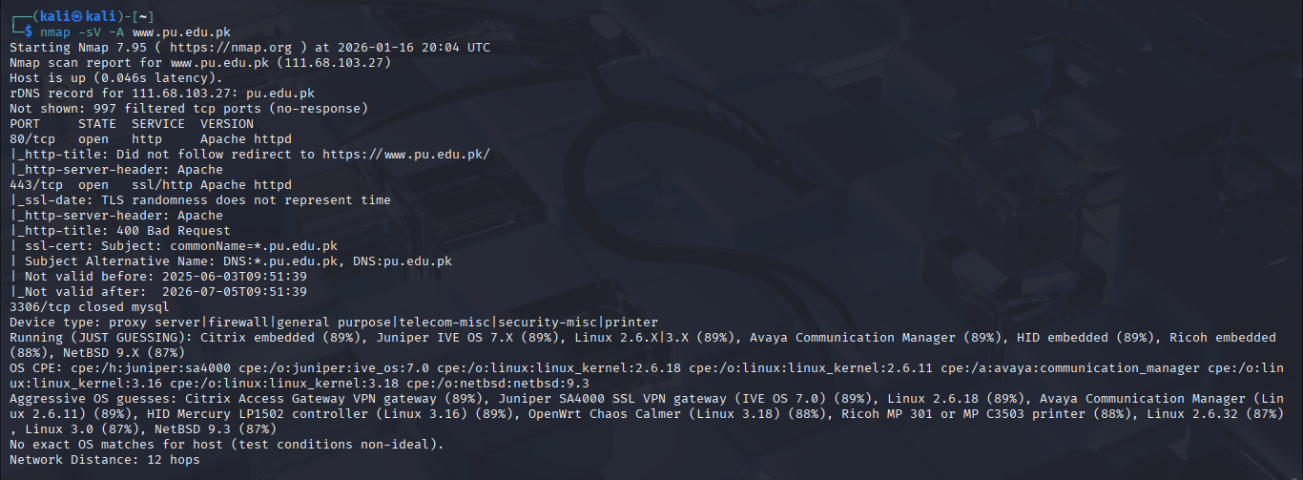

SSLScan
Objective:To analyze the SSL/TLS configuration of the target web server.
Method Used:SSLScan was used to enumerate supported SSL/TLS protocols and cipher suites.
Result:The scan revealed enabled SSL/TLS versions and supported cryptographic ciphers.
Security Impact:Weak or outdated encryption protocols can expose sensitive data to interception.
Risk Level:Medium

